**Module 1**

**Part 1. Your primary response**

Select one product of your choice (e.g., a computer, video camera, watch, jacket, purse, car, etc.).

Search on the Internet for at least 10 different vendors (you can find several vendors on eBay, Amazon, etc.).

Collect the product price per vendor and prepare a table in Excel, include the names of the vendors, website, price of the product and shipping cost (if applicable).

Include descriptive statistics of your data set: mean, SD, median, maximum, minimum, range.

**IMPORTANT:** Insert your table as a JPG image.

Make sure your table has a professional look.

Finally, answer the following questions:

1. Did you find any challenge on your data collection procedure?
2. Was your data collection random? Explain how did you select the 10 vendors.
3. Based on the data collected and statistical analysis, what can you tell us about the distribution in prices? Apply critical thinking.

**Part 2. Your two replies to classmates**

In this part you must apply critical thinking to provide your classmates with meaningful observations about their primary responses, and provide observations and recommendations where their work can be improved.

Do not limit yourself to comments like: "I agree with your presentation," always explain the reason.

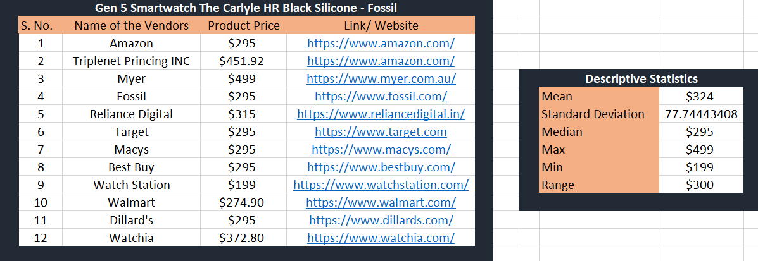

1. Initially, it was difficult to find the appropriate link to the product but later on with thorough research and choices I am able to collect the data accordingly from opensource mediums

2. The Data collection was picked randomly from set of vendors who are selling this product. I have selected based on the product attributes, pricing, features, similarity, and reviews

3. More Vendors can be added to the list to get more idea on the analysis. Most of the vendors were median priced